debs
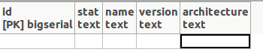



Run command: create_flavor -f ~/Documents/Doveps/mono/savant/flavor/ -n ubuntu-14.04.1 -s ~/Documents/Doveps/mono/scanner/local/33.33.33.50/
We want to use the API here. So the command will be something like
curl -X POST savant-server:5000/api/flavor/create
You’ll need a payload for the POST request, including the file from scanner/local/33.33.33.50, and also including the name of the flavor.

debs 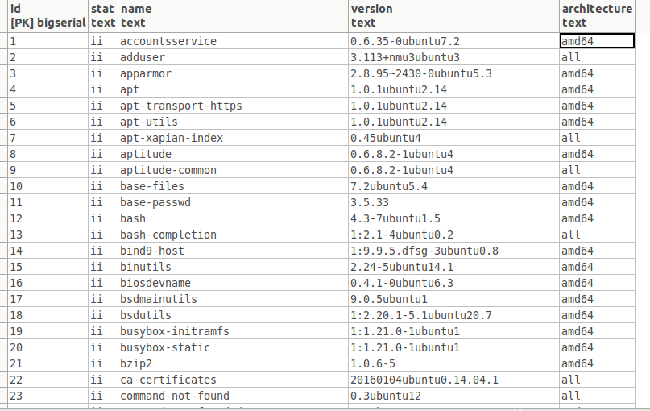

Adding rows is correct. There should be no duplicates in the debs table.

You will need two more tables: flavors (includes flavor name), and flavors-to-debs (many-to-many relationship between flavors and debs tables)

New Table is then automatically created:

debs2
I’m not sure whether you need a debs2 table. This depends on how you compare a scan with an existing flavor. Do you need a temporary table?

